Tutorial on AMP-PepPI
This tutorial provides a step-by-step guide on predicting peptide-protein interactions (PPI) between antimicrobial peptide (AMP) and their target proteins using AMP-PepPI.
Upon visiting the AMP-PepPI homepage, users can initiate the prediction process by clicking the “Prediction” button on the left side, as shown in Figure 1.

Figure 1: Homepage of AMP-PepPI
Providing Input Sequences
Users can input AMP and protein sequences in two ways:
- Paste the sequences directly into the respective text boxes.
- Upload sequences in FASTA format.
Additionally, users can:
- Provide pre-defined AMP-protein pairs for interaction prediction.
- Input a variable number of AMP and target proteins and generate all
possible pairwise combinations for analysis (Figure 2)

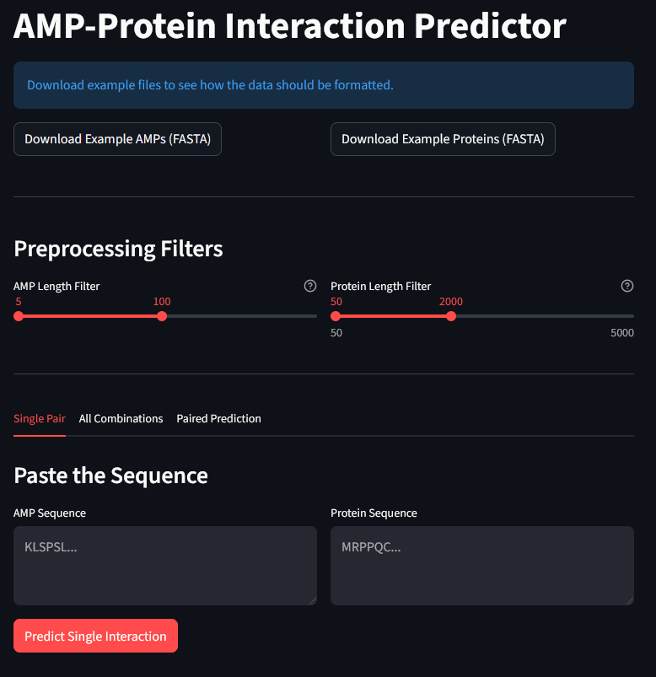
User can apply a length filter to both AMP and protein sequences by dragging the provided bar.
a)
Example sequence of AMPs and proteins can be downloaded here.
Paste input AMP sequence here.
Paste input protein sequence here.
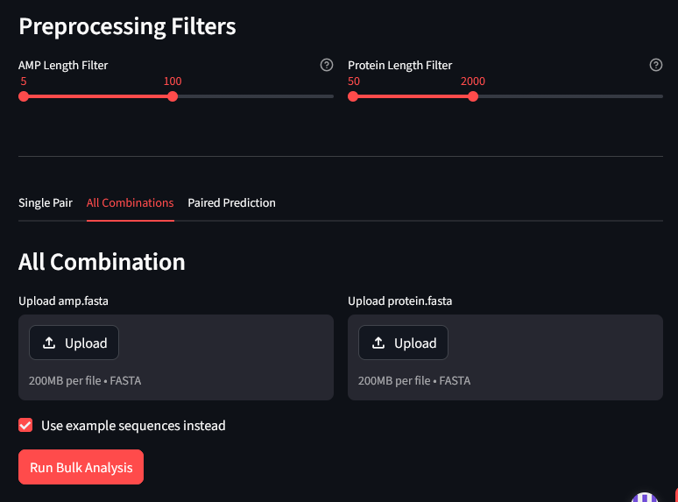
b)
Click here to run example sequences for all combinations.
Upload a fasta file of AMP and protein separately.
To predict PPI between all possible pairwise combinations of Amp and proteins use this option.
Click here to run example sequences for paired prediction.
To predict PPI between paired Amp and proteins use this option.
c)
Figure 2: View of the prediction tab. a) Option to paste the sequence(s) in respective tab. b) and c) Option to upload the sequence(s) in fasta format.
Viewing and Interpreting Results
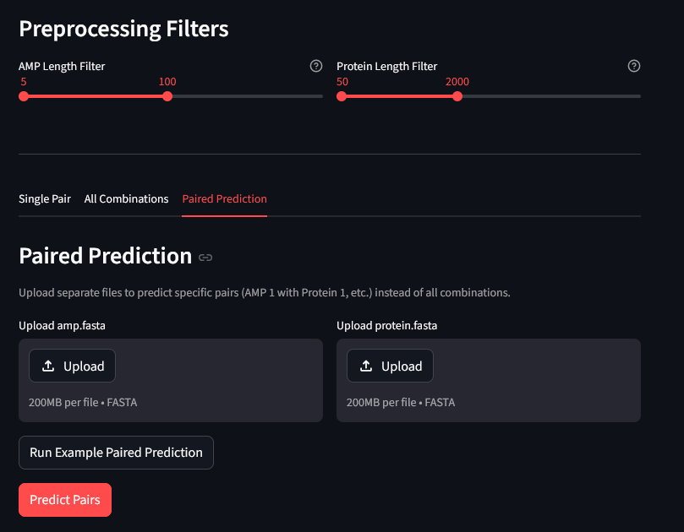
Predictions are displayed in a tabular format and can be downloaded for further analysis (Figure 3).
Prediction outcomes:
- 1 → Positive interaction predicted.
- 0 → No interaction predicted.
Each prediction includes an interaction probability score.

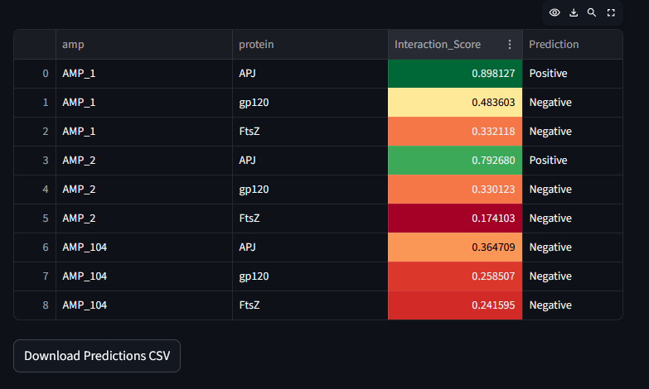
Click here, to download the predicted results in csv format.
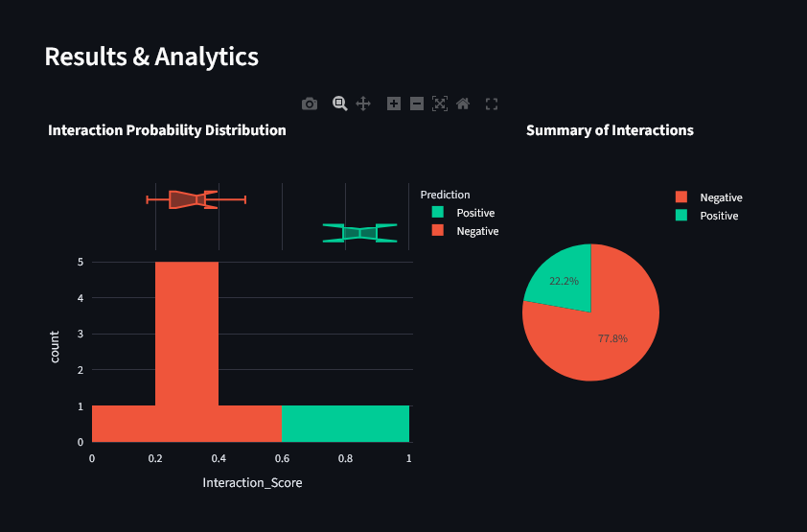
Figure 3: Result view.
In the given example, the result shows that the probability of interaction between the first and third given protein pairs is 100%. ‘1’ in the ‘Prediction’ column means that the model predicted positive interaction. Whereas, second pair as well as the bottom five pairs have a higher probability of not interacting and hence the final prediction was in favor of negative interaction or no interaction represented by ‘0’.
Downloading and Analysing Results
Users can download results for offline analysis. The downloaded results can be viewed in Excel or any spreadsheet tool (Figure 4).

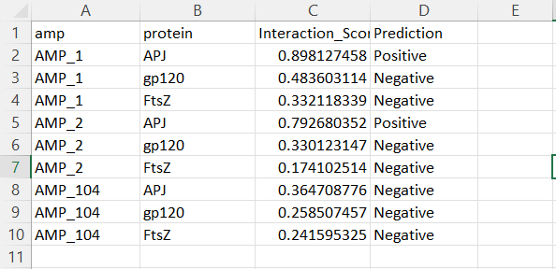
Figure 4: Snapshot of the result

